Name
MGT
Individual Paper

APA Issue from https://apastyle.apa.org/style-grammar-guidelines/paper-format

Format
Cover Page - TITLE IN CAPS and Properly Formatted
Use the Cover Page Provided in the Course Documents
Same Font as a Paper

Table of Contents (TOC)
Proper Margins/Headings/Page Numbers/Actual Page Number (roman) Same Font as a Paper

Page 1 – TITLE IN CAPS
Match the Cover Page

Page Numbers
Same Font as the Paper Restart Page Numbering
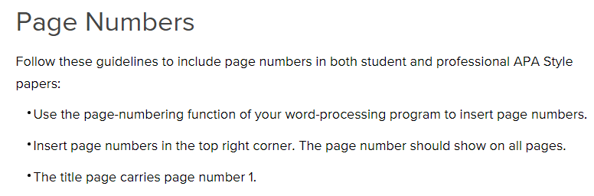
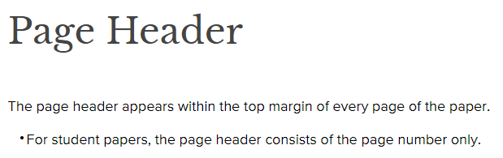
No Running Heading

Font Size – 10-12”

Spacing
Double Space Throughout

Headings
Major Headings are Centered/Bold/Same Font as Paper

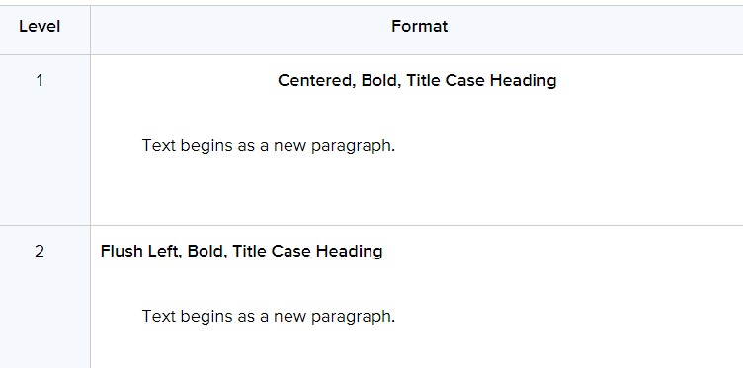
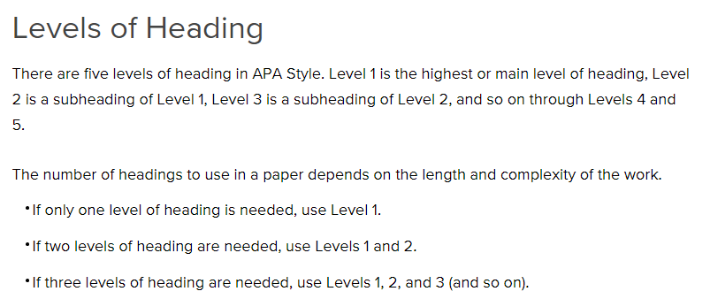
Matches the Table of Contents (TOC)

Margins – 1” all around

Reference Page
Proper APA Style – See APA Handout or Purdue OWL

In-text Citation
Proper APA Style – See APA Handout or Purdue OWL

Quotes
Quotes Are Introduced or Closed Out Properly with APA
Long Quotes/Block Quotations – 40 words or more (typically more than four lines)
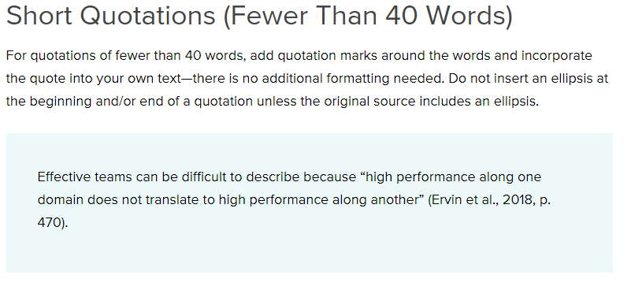

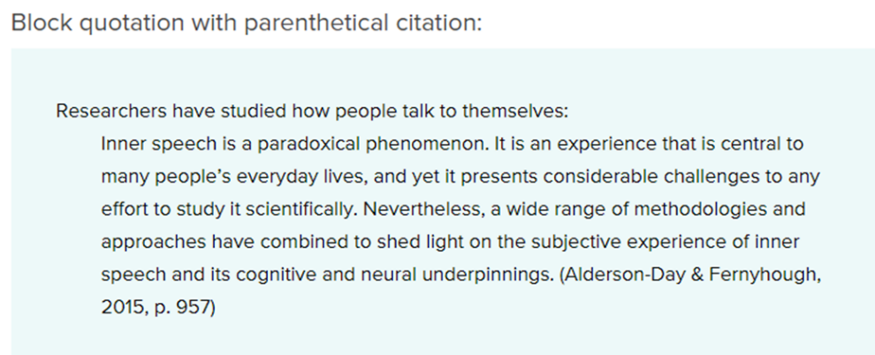

Tables and Figures (if used)

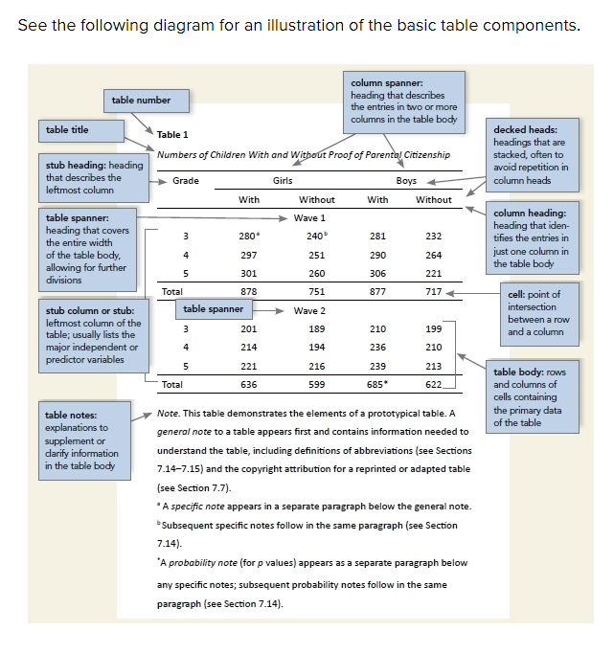

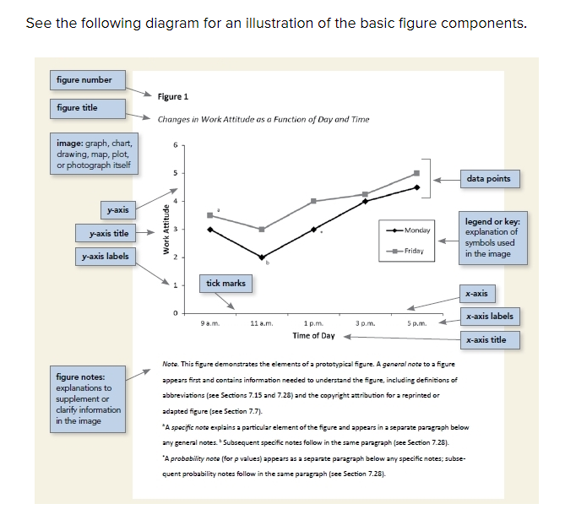

1. Introduce the Table or Figure

2. Show the Table or Figure

3. Discuss the Table or Figure

Punctuation and Grammar
Typos Punctuation Phrasing/Wordy Spelling

Content
Thesis Transitions Logical

